A Longitudinal Analysis of Historical Mental Health Reports with Regards to Internet Use
1903299 Connor Murphy PSY567
Unit 2 report

Introduction
In the modern world, the internet has become a constant part of the majority of people's lives. Despite being less than 50 years old, the internet has caused vast cultural changes and created communities that have never seen each other's faces. However, this cultural evolution occurred so rapidly that none of the potential side effects were truly studied. The most debated of these side effects is whether prolonged internet usage causes depression. To answer this question, this paper will use historical psychology methods to explore any potential correlation.
Keywords: science/humanities integration, mental health, longitudinal study, cultural analysis, internet use effects, overview of cultural changes.

The methodology of historical psychology is a fairly new concept, which argues that to understand a culture's attitudes and practices, you need to look at its past. Michael Muthukrishna et al wrote a paper on the topic, giving examples of the origin of many Western and Eastern cultures. These included significant findings that propose that cultures following the catholic faith are far more likely to have monogamous marriage, despite “approximately 85% of human societies in the anthropological record having permitted polygamous marriage” (Muthukrishna, 2021). Other findings suggest that cultures that house the Catholic Church tend to have a more analytical approach to their thinking. Furthermore, these people are more likely to be charitable, welcoming and put “more trust in out-groups relative to in-groups” (Muthukrishna, 2021). Muthukrishna does highlight some issues with this methodology, in that historical data tends towards being testimonial accounts.
This methodology finds its data through provable inference based on writings and artefacts, making it difficult to find data that can be directly compared to modern trends. Muthukrishna's work highlights the importance of seeing the problem as part of the wider whole, with many other factors contributing to a potential finding.
As previously discussed, the relationship between internet use and depression was highly debated, but a paper by Xin Fang Et Al attempts to clarify this by performing a cross-lagged analysis. Fang took 677 middle schoolers for three sessions over two years and prompted them to fill out questionnaires measuring depression, loneliness and their level of internet use. From the analysis of the questionnaires, Fang discovered that “depression could significantly and positively predict PIU, while loneliness could not.” (Fang, 2023). Conversely “PIU could significantly and positively predict the feelings of depression and loneliness” (Fang, 2023). This pattern held for both genders; this bidirectional relationship between depression and internet use is verified by other similar studies, suggesting that depression and social media use feed into each other, only exacerbating the problem.
Fang highlighted an issue that this project finds important, being that this research was carried out on Chinese children who grow up in a collectivistic culture, meaning that they may view social media use differently than Western children. Additionally, this project found that this paper only included participants with extreme social media use, so we don’t know if the bidirectional relationship also holds for casual users.
Learning from previous findings and limitations, this project aims to generally explore the topic using historical psychology methods. The digital age and the introduction of the internet are relatively new compared to the usual sources of historical psychology data. Meaning there is a better chance of finding quantitative data that can be properly used for this project’s purposes. By referencing this data, it can be explored whether different demographic groups followed the same trends as those found today as there were methods of socialising before social media, such as chatrooms. To address the issues found in Fang’s paper, this project will expand its analysis to include different demographics. Through this, this project hopes to analyse data for correlations between internet use and mental health over the last few decades and potentially verify other papers' results over a wider cross-section of people.

Dataset
The dataset this Project used was the General Social Survey (GSS) started by James A. Davis in 1971. The GSS is a collection of national representative surveys answered by Americans of all ages. The surveys started with basic demographic and opinion-based questions on various topics. As time went on, new questions on emerging topics and technologies were added. Through analysis of the survey results, the attitudes and behaviours of the American people can be discovered. (Davern Et al, 1971-2024).
The variables of most interest to this project were wwwhr, a measure of how many hours the participant has spent using the internet in the last week and mntlhlth a measure of how many out of the last 30 days has the participant felt depressed. mntlhlth only has data going back to 2000 meaning that this project cannot investigate the effects of the early internet on mental health.
However, wwwhr, mntlhlth can be filtered by how much participants use the internet to different extents. To fully achieve our aim, the data will need to be grouped into various demographic and socioeconomic sections. To do this, the variables age and total family income will be used to create several demographic groups from which a wide range of findings can be gained.
The analysis of these groups was focused on the distribution of the groups visualised through pie, bar and box and whisker graphs, showing if a certain group is more predisposed towards using the internet or perhaps highlighting any flaws in the methodology of the GSS surveys. The other focus was the correlation coefficients between a group’s internet usage and their mental health and how these correlations change over time, implementing the historical psychology methods discussed previously. The normal distributions of each group's data were found using the Kolmogorov-Smirnov method due is non-dependency on non-parametric data. It was found that there was a mix of normal and non-normal distributions, so the Spearman's rho method was used. As it doesn’t depend on the data being parametric or the number of data points in each group the Spearman's rho method will give a more robust and trustworthy answer.

Results
As there are 10 groups in total, only one or two graphs of each type will be displayed in this section for the sake of brevity. All further graphs can be found in the Appendix.

Figure 1 Line graph representing the distribution of participants in each income group

The income groups were split into 3 groups with low, medium and high based on the 12 levels of options given in the GSS survey. These groups were then further divided by high and low internet usage. The split was made by finding the median value for internet usage in the given year. As shown in Figure 1 and in the appendix the high income groups vastly outweigh the medium and low income groups in terms of data points.

Figure 2 box and whisker graph representing the distribution of participants recorded mental health in each income group
When the mental health of the income groups is displayed as a box and whisker graph, the distributions for the groups can be seen. As evidenced by Figure 2, the groups tend to be largely similar with subtle differences. This may indicate a lack of significant difference between groups, but further analysis will be needed to confirm this hypothesis. As shown in the appendix, when the groups are viewed year on year, differences can be seen, but this is to be expected when potentially different people belonging to a particular group complete a survey.

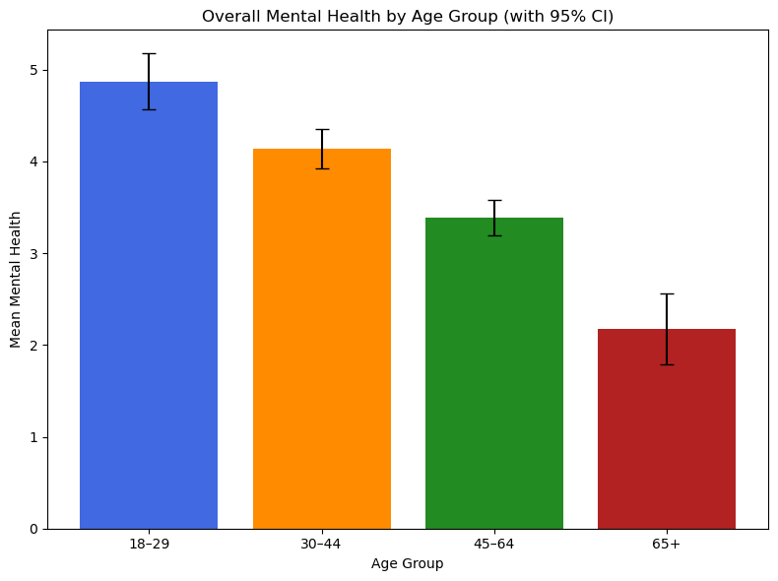
Figure 3 bar graph representing the differing over all mean mental health for each age group
As seen above, the overall mean mental health appears to reduce as a person ages, by a standard amount every 15 to 20 years.
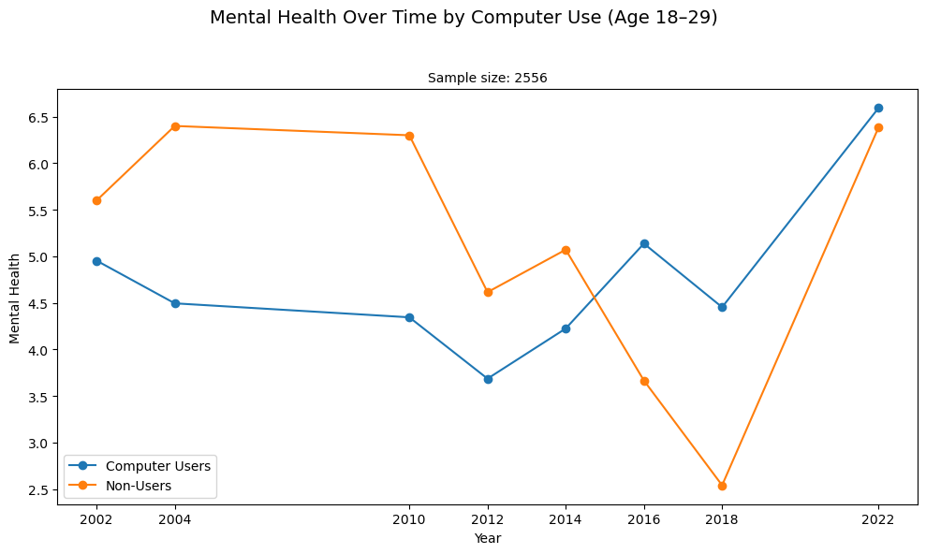
Figure 4 line graph representing the differing mean mental health for internet users and non-internet users

When observing the mean mental health for internet users and non-internet users in each age group, a surprising trend can be seen. Usually, the non-internet users tend to have a higher mean mental health value compared to internet users. This trend continues until the over-65 group, where the trend flips.

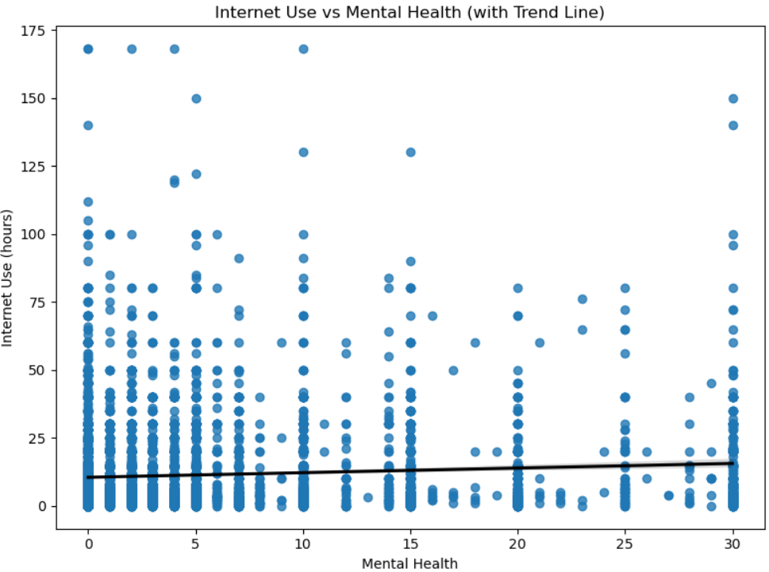
Figure 5 Line graph representing the distribution and correlation between internet use and mental health

A Spearman’s correlation was conducted to evaluate the relationship between overall internet use and overall reported mental health. There was a significant positive relationship between overall internet use and overall reported mental health, r_{s}(38) = 0.076, p = < .001.

Figure 6 Line graph with error margins showing the correlation coefficients for the income groups overtime

As shown above in Figure 6, the high-income groups are stable around 0 correlation. This is probably due to the abundance of data points reducing variability. The other groups vary wildly, with both medium income groups and the high internet usage low income group, starting with a negative correlation, but over time become positive. With low internet usage and low income, it forms a wave dipping between positive and negative correlations.

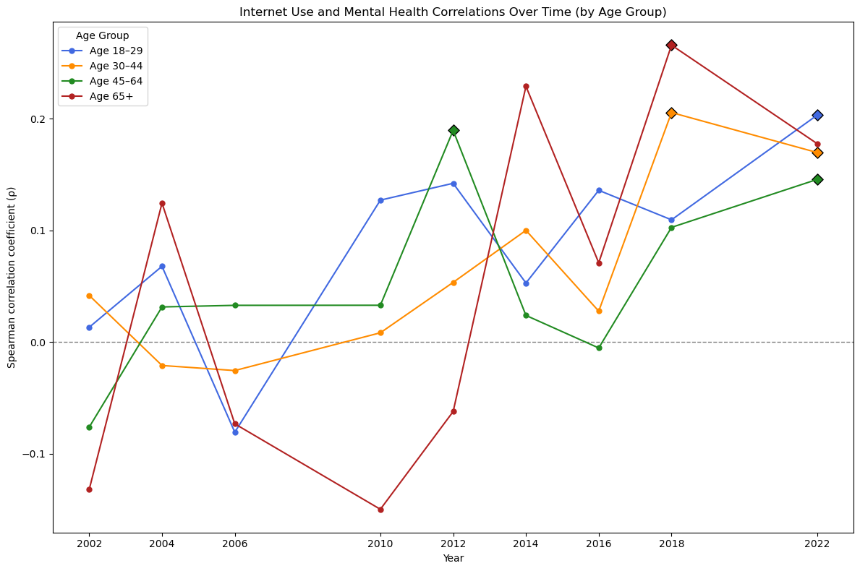
Figure 7 Line graph showing the correlation coefficients for the age groups overtime

Figure 7 shows that each age group started with an even mix between positive and negative, and then generally grows until each group’s correlation is slightly positive, rising and falling on their gradual upward trend.

Discussion
There are a few conclusions that can be drawn from the results of the analysis in relation to this project’s aims. Starting with the distribution of the groups, each of the age-based groups has plenty of data, each one having around 2000 to 4000 data points, except for the eldest group, which had around 900 data points. This is enough data to have a good confidence in the results. However, with the Income groups, there is a huge disparity between the low/middle and the high income group. Even without splitting the income groups by level of internet usage, the income groups would still be very unbalanced. This project could have sectioned the data better by using the quartiles of the data, but this project sees that as misrepresentative. As such, any insight gained through analysis of such limited data is highly questionable.
The distribution of reported levels of negative mental health show some interesting trends, especially in the age groups. The box and whisker graphs of the mental health of the income groups show wild variation for the low and medium groups, whereas the high income groups show slight variations of 3 to 5 over time. This is most likely due to the scant number of data points for the low and medium groups. The consistently low mental health suggests that people with high income are less depressed, potentially due to a lack of financial stress. The distribution of the age groups' mental health is very interesting, as it decreases with age. This matches other research in the field, as it has been proven that age positively correlates with reported positive emotions (Yeung, 2011). It is theorised that this is due to a person initially using a response-focused system to regulate emotions. These systems react to an emotion once it is felt. However, as a person grows older, they start implementing antecedent strategies that involve reappraising the situation before an emotion is processed. Through this, older people are less responsive to negative influences and for this project, older people may be more resistant to the negative influences encountered while using the internet.
Another interesting discovery is that, according to this data, a non-internet user is more likely to be depressed than an internet user. There is little to no research on why this may be, but this project theorises that non-internet users may not have the range of social connections internet users may have, potentially increasing feelings of loneliness and other negative emotions.
Finally, the correlations over time contribute most to answering this project's research question. Initially, when taken, there was a slightly significant positive correlation between internet use and reported mental health for the income data, but when it was split into groups, no significant correlations were found with p values ranging from .059 to .924. This is further corroborated by the high-income groups with the most data points staying constantly around zero, suggesting that income does not affect the relationship between internet use and bad mental health. The age groups are very interesting as they grow in positive correlation over time. Although growth overall results in an increase of around 0.2 to 0.4, resulting in a very weak positive correlation for all age groups potentially mirroring findings of rising mental health problems in teenagers. However, further analysis is needed to establish whether people’s internet usage is slightly changing to match reported mental health or the other way around potentially through a cross-lagged analysis like Fang’s work. In summary, this project's analysis of the GSS dataset revealed that income seems to have no effect on the relationship between internet usage and reported mental health. Age, on the other hand, appears to show a slight positive increase over time. From this minimal level of demographic sectioning, this project suggests that differing demographic groups may have a slight difference in remote mental health struggles.

References
Davern, Michael; Bautista, Rene; Freese, Jeremy; Herd, Pamela; and Morgan, Stephen L.; General Social Survey 1972-2024. [Machine-readable data file]. Principal Investigator, Michael Davern; Co-Principal Investigators, Rene Bautista, Jeremy Freese, Pamela Herd, and Stephen L. Morgan. Sponsored by National Science Foundation. NORC ed. Chicago: NORC, 2024: NORC at the University of Chicago [producer and distributor]. Data accessed from the GSS Data Explorer website at gssdataexplorer.norc.org.
Muthukrishna, M., Henrich, J., & Slingerland, E. (2021). Psychology as a historical science. Annual Review of Psychology, 72(1), 717-749.
Fang, X., Tian, M., Wang, R., & Wang, P. (2023). Relationships between depression, loneliness and pathological internet use in adolescents: A cross-lagged analysis. Current Psychology, 42(24), 20696-20706.
Yeung, D. Y., Wong, C. K., & Lok, D. P. (2011). Emotion regulation mediates age differences in emotions. Aging & mental health, 15(3), 414-418.

Appendix
Group Exploration by Year
2002

2004

2006

2010

2012

2014

2016

2018

2022

Overall Age Groups Exploration
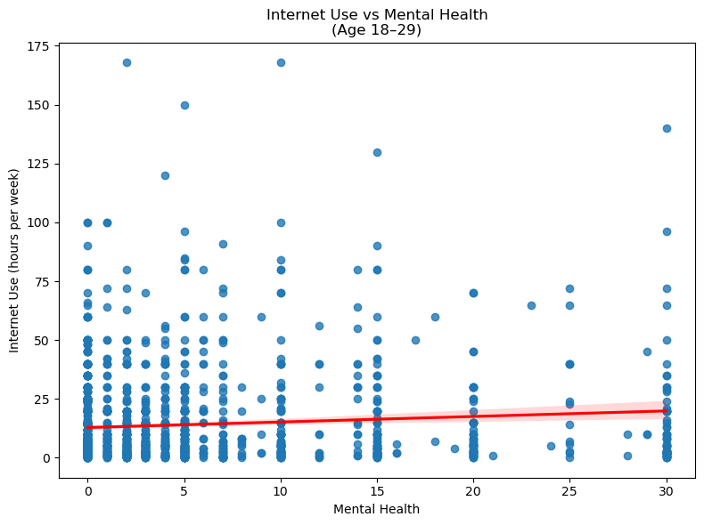
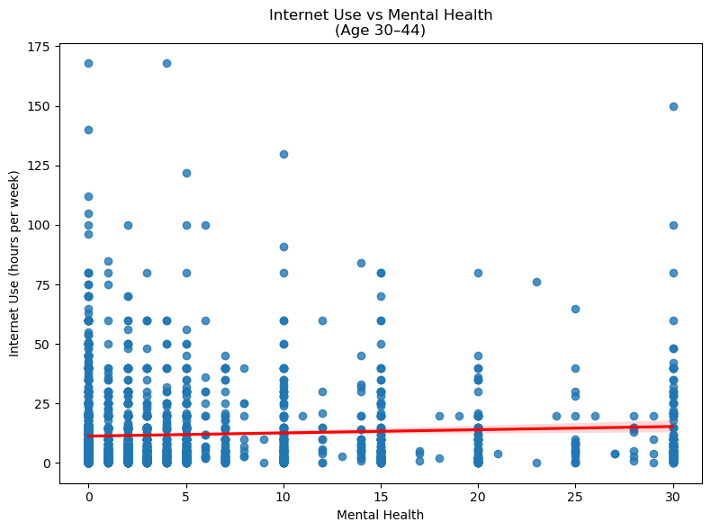
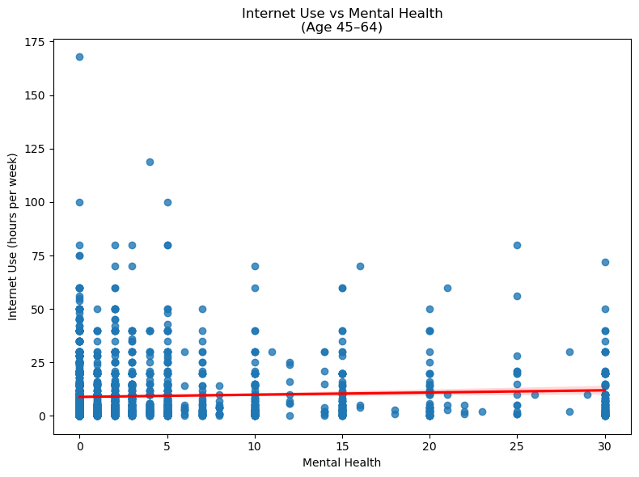
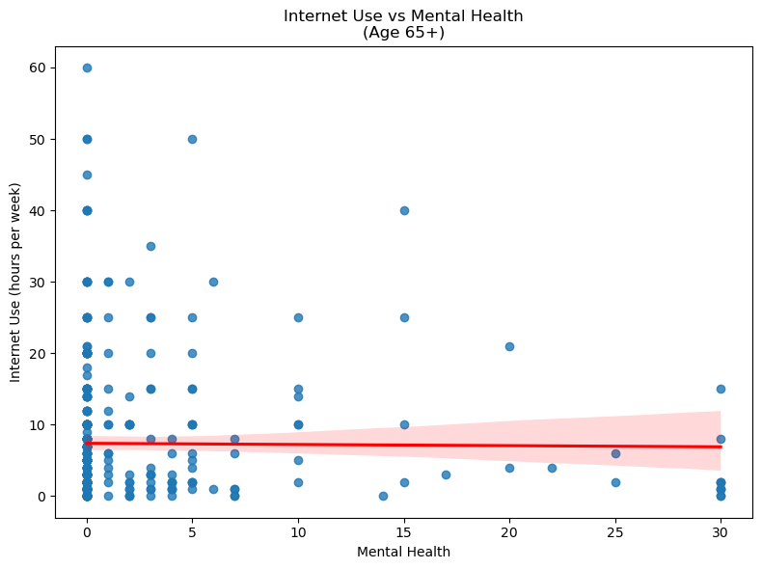

Age Group Comparison between meen internet users and non-users by year


